**V. Results**

To confirm the findings of the Cointegration Approach paper of 1997, we decided to rerun an analysis on the 10 year treasury rates and AA and B indices on the period 1997-2022. The dataset was taken from the FRED Federal Reserve Bank of Saint-Louis.

Figure 1

We see that in the period from 1997-2022, the B and AA spreads, reach higher values. We can also confirm that the volatility of the B spread 2.54 is higher than the volatility of the AA spread 0.694.

Figure 2

Figure 3

We can also see from the data that there is negative correlation between the change in the Baa spread and the change in the 10-year Treasury Yield that coincide with the results of the Cointegration approach. This is also the case for the change in the AA spread.

Figure 4

We also found that the correlation coefficient between the change of the AA spread and the change in the 10 year treasury yield is very close to the correlation coefficient found in the paper of 1997. We found it to be -0.3512, while the paper obtains -0.34.

Similarly, we found that the correlation between the change of the B spread and the change in the 10 year treasury yield is also very close to the one found in the paper. We found it to be -0.4195, while the paper they revealed is around -0.47.

Nevertheless, the long term effect for the B spread does not hold. The paper estimates the 36-month-lag coefficient to be around 0.18, while we found it was 0.0217 for our sample period. The long term effect for the AA spread was estimated to be close to 0, and we found a close result: 0.021.

Figure 5

The objective of the project is to use BDT lattice models to price callable bonds with the traditional approach and with one that incorporates the findings of the Cointegration approach paper. In the first approach we will build a BDT lattice model of the risk-free interest rate and assume a constant credit spread that will be extracted from the non-callable bond data. For the second approach, we will construct a credit spread lattice using the correlations of the changes in the interest rate and the changes in the credit spread.

The first set of data includes the callable and non-callable bonds found in the ICE website as of 6/30/2022. The first step is to complete the current spot rate curve with the spot rate values known. These values are the ones taken as of 6/30/2022 from the FRED Federal Reserve Bank of Saint-Louis. The missing maturities are obtained from linear interpolations of known values.

Figure 6. Spot Rates as of 6/30/2022

The discount values for each maturity can be computed using the following equation.

***D(T) =***

Figure 7. D(T) values.

With these values, we are going to calibrate our BDT- risk-free lattice. The idea is to select the risk-free values at the nodes, that satisfy the D(T) values calculated previously. It is important to notice that the following relationship holds at each node.

Figure 8. Risk-free rate Lattice.

For the traditional approach, the credit spread is going to be extracted from the Option Adjusted Spread that is found in the non-callable bond data. Therefore, this work is only going to be focused on companies that have both callable and non-callable debt information available. Some companies have several OAS, given that they have several non-callable debt with different maturities. In these cases, the OAS will be obtained using a linear interpolation from the available values.

For the Cointegration approach, the first node of the credit spread lattice will be set to the OAS from the non-callable bond data. The value in the other nodes will depend on the changes of the interest rate that occur in the risk-free lattice. We use the following formula to obtain the value of the credit spread at each node:

$${cs}_{i,t}={cs}_{i-1,t-1}+\frac{ (r_{i,t}-r_{i-1,t-1})}{r_{i-1,t-1}}*corr*{cs}_{i-1,t-1}$$

Where $corr$ is the correlation coefficient between the change in the interest rate and the change in the credit spread. According to the Cointegration Approach paper and our findings on the recent data, this correlation coefficient is of -0.16 on the AA spread and ----0.42 in B spread. Summing the values of the interest rate lattice and the credit spread lattice, we will obtain the yield lattice. This yield lattice will be used as the discount rate in our bond lattice.

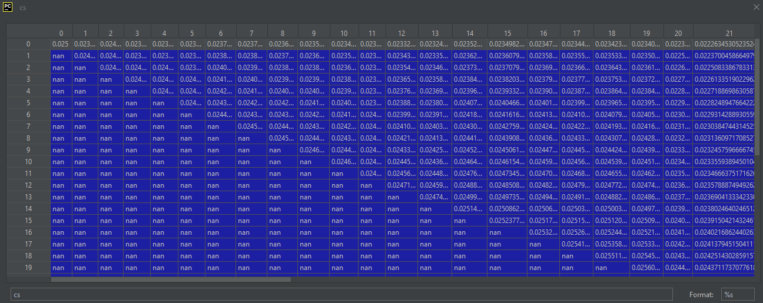

Figure 9. Credit spread lattice for AA bond.

The bond lattice will be constructed using the yield lattice. We will start by filling the last column. The values on these nodes are the value of the bonds at maturity, which is $FV+Coupon/2.$ For all the other nodes, the company will call the bond if the exercise value is smaller than the continuation value. Therefore, the value of the bond at each node will be given by this formula.

$${CB}_{t,i}=min⁡\left[FV+C/2, \frac{1}{1+\frac{{yield}_{t,i}}{2}}*\left(q*{CB}_{t+1,i}+\left(1-q\right)*{CB}_{t+1,i+1}\right)+C/2\right]$$

We will fill all the other values of the lattice until we get to node (0,0). The value of this node is the estimated price of the model.

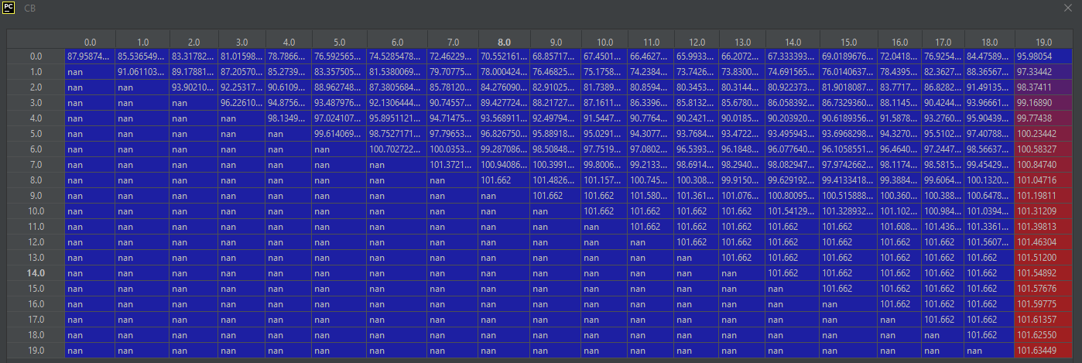

Figure 10. Bond Lattice Example.

Initially, we calibrated the BDT risk-free rate tree with a constant volatility value of 0.0208. This was calculated as the historical volatility of the treasuries for the last 20 years. However, this value is very low, because it does not contemplate sufficient scenarios in which the bonds are exercised. So, we also used volatility values of 0.10, 0.20 and 0.30.

Our initial dataset has 312 Investment Grade and 14 High Yield Bonds. Below you can find the results for the different versions of our model.



Figure 11. Results.

**VI. Conclusions**

* The Investment Grade bonds in our dataset are called more frequently than the High Yield bonds. Given the high spread of the High Yield Bonds, it is common to see that the continuation value is almost always smaller than the exercise value, which means that for this group generally, the bonds are not likely to be called.
* The models that incorporate the Cointegration Approach have a similar performance to the standard models that assume a constant credit spread. However, they do not improve the performance. This could be explained partly by the fact that this relationship is not contemplated by the individuals who trade these securities.
* The models tested in this project, have a better performance on the Investment Grade category. This can partly be explained by the liquidity factors that surround the High Yield Bonds as these can have effects on prices that are not contemplated in our model.
* Our models have better performances when there is a high volatility assumption. This means that the traded prices contemplate high volatility scenarios.